**Subject Code:** ITC515

**Subject Name :** Professional Programming Practice

**Assignment Number:** 04

**Lecturer Name :**  Recep Ulusoy

**Student First Name :** Akila Kanishka

**Student Surname (for searching) :** Gangodage

**Email Contact:** gakanishka@gmail.com

**Student ID :** 11628458

|  |
| --- |
| Charles Sturt University |
| **Debugging** |
| **PROFESSIONAL PROGRAMMING PRACTICE : ASSIGNMENT 04** |
|  |
| Akila Kanishka Gangodage |
|  |

**Debugging Logs**

Git Repository: <https://github.com/AkilaKanishka/HotelApp>

UAT Test Script: <https://github.com/AkilaKanishka/HotelApp/blob/master/UAT%2BTest%2BScript.docx>

Debugging Log: <https://github.com/AkilaKanishka/HotelApp/blob/master/debugging-log.docx>

1. All Service charges are reported as 0.00 when checking out

* In checkoutCTL.java set the debug point at line number 66

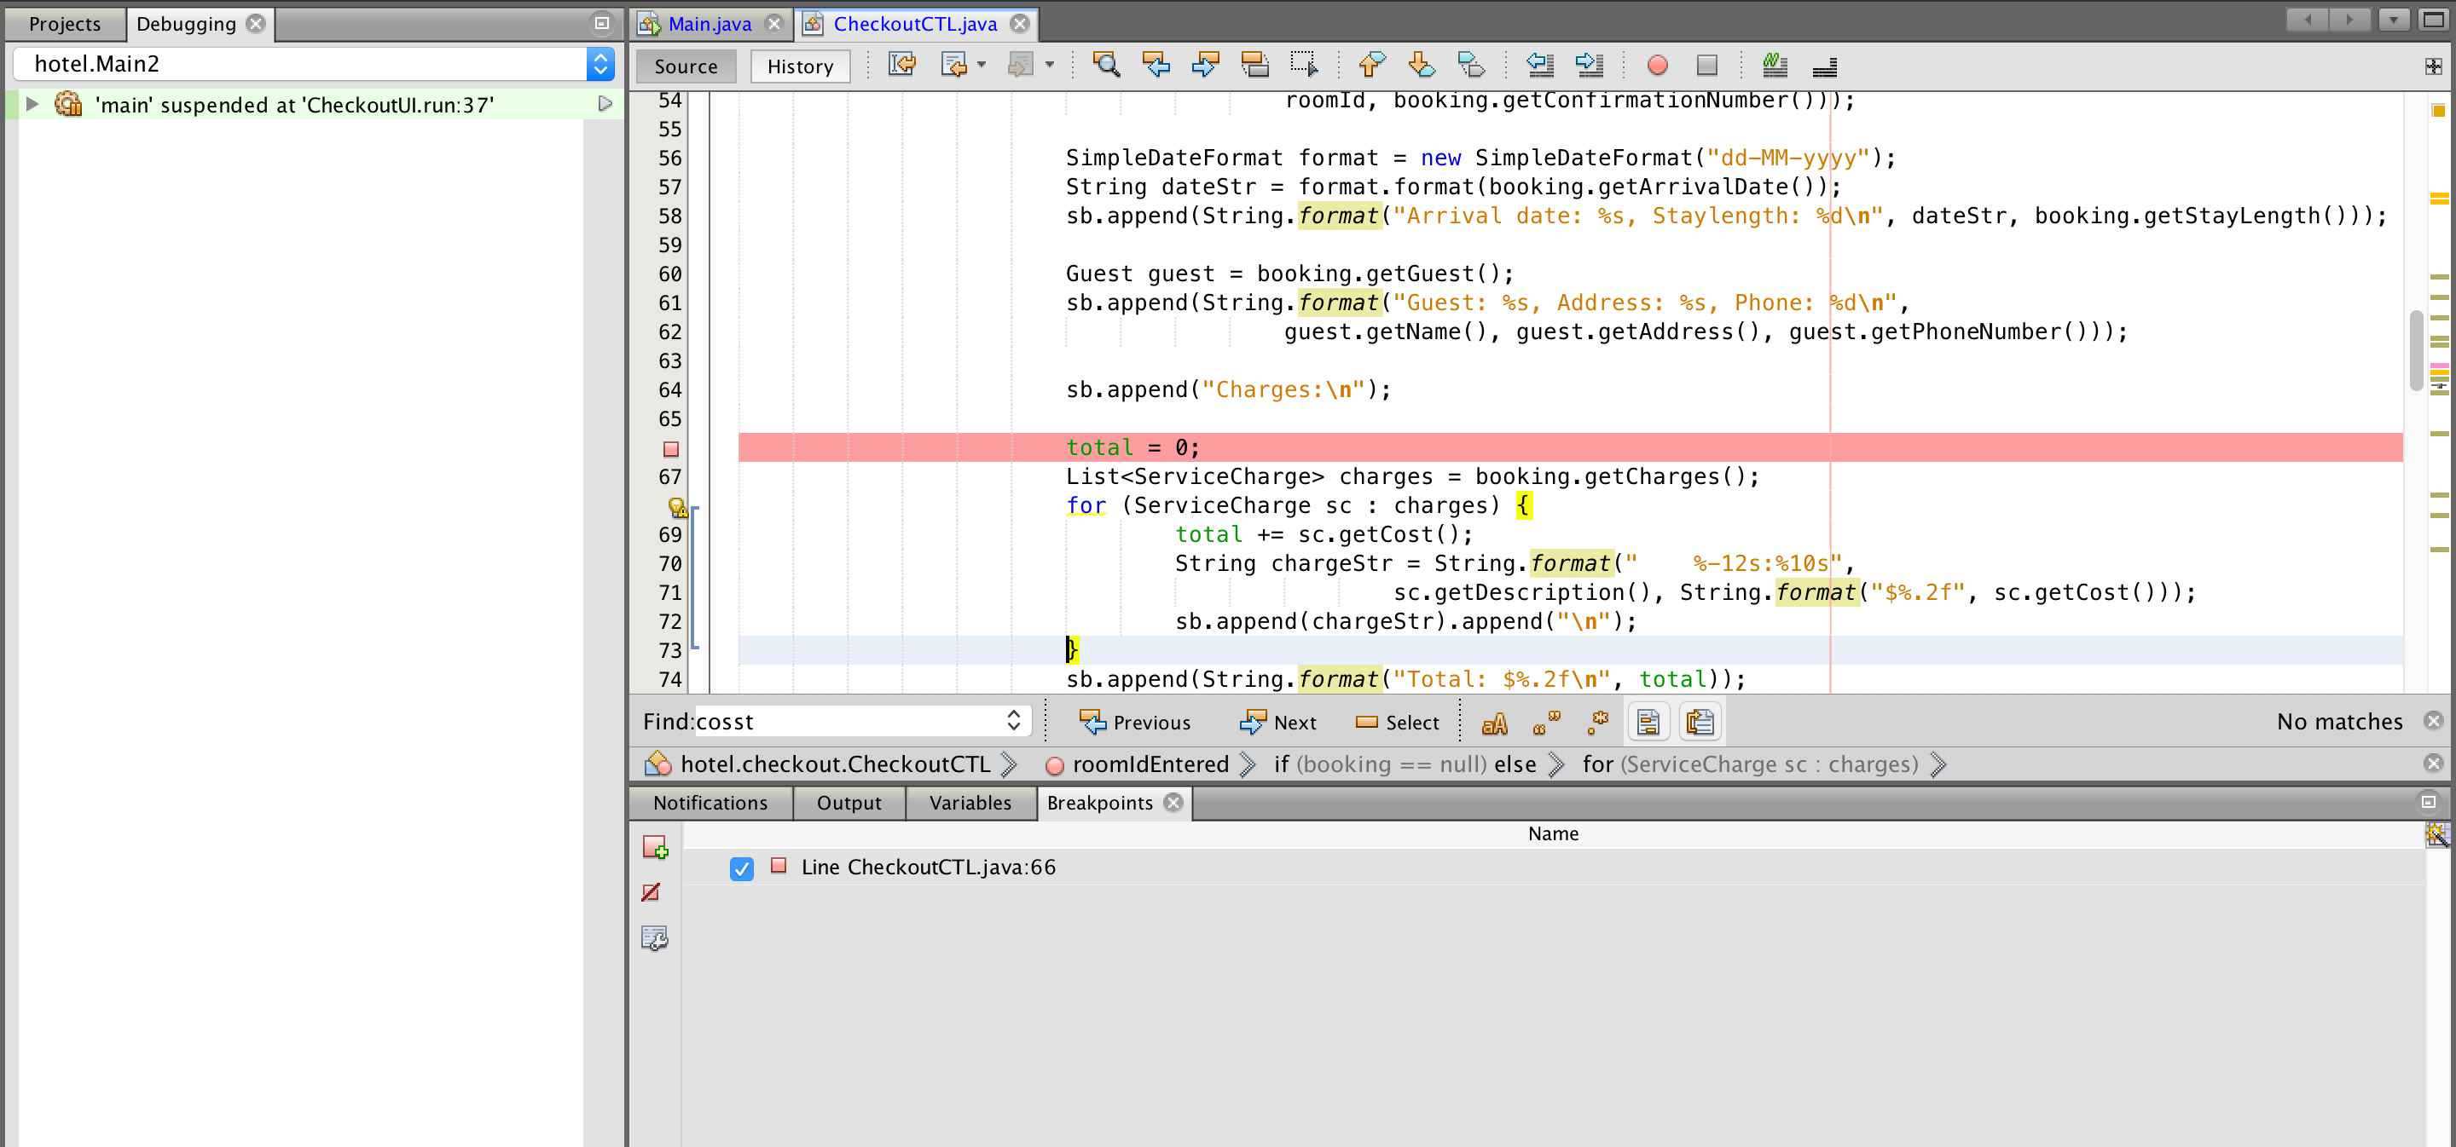

* when I Debug the file I could notice that the variable “*total*” wasn’t updated because ‘*charges’* object list always returns the 0.00 for the ‘*cost’* variable

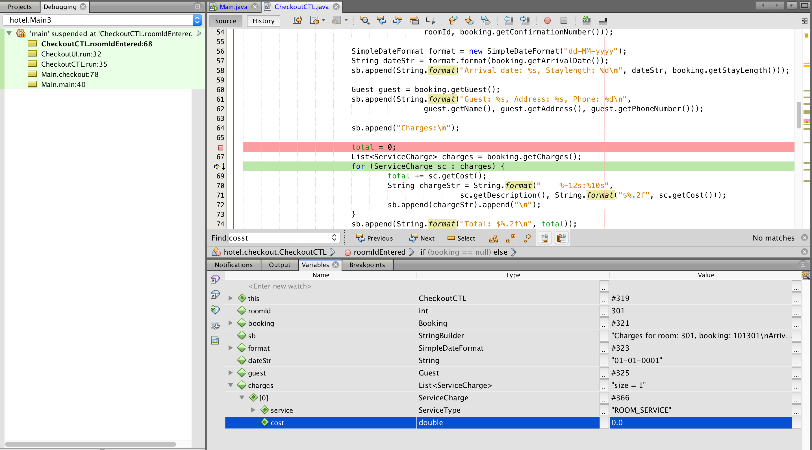

* The reason for this issue should be ‘*cost’* variable is not being set the value so then I set the debug point Booking.java file where set the value for ‘*cost’* variable
* Set the debug point in Booking.java file at *addServiceCharge* method (line number 142)

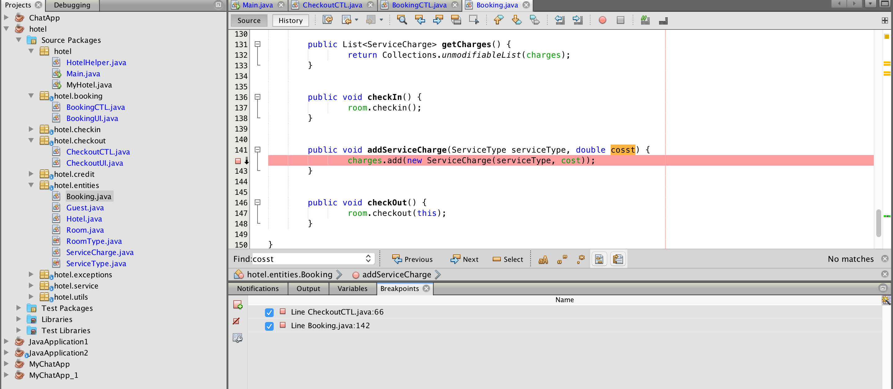

while debugging the Booking.java file we can see in the variable list as following

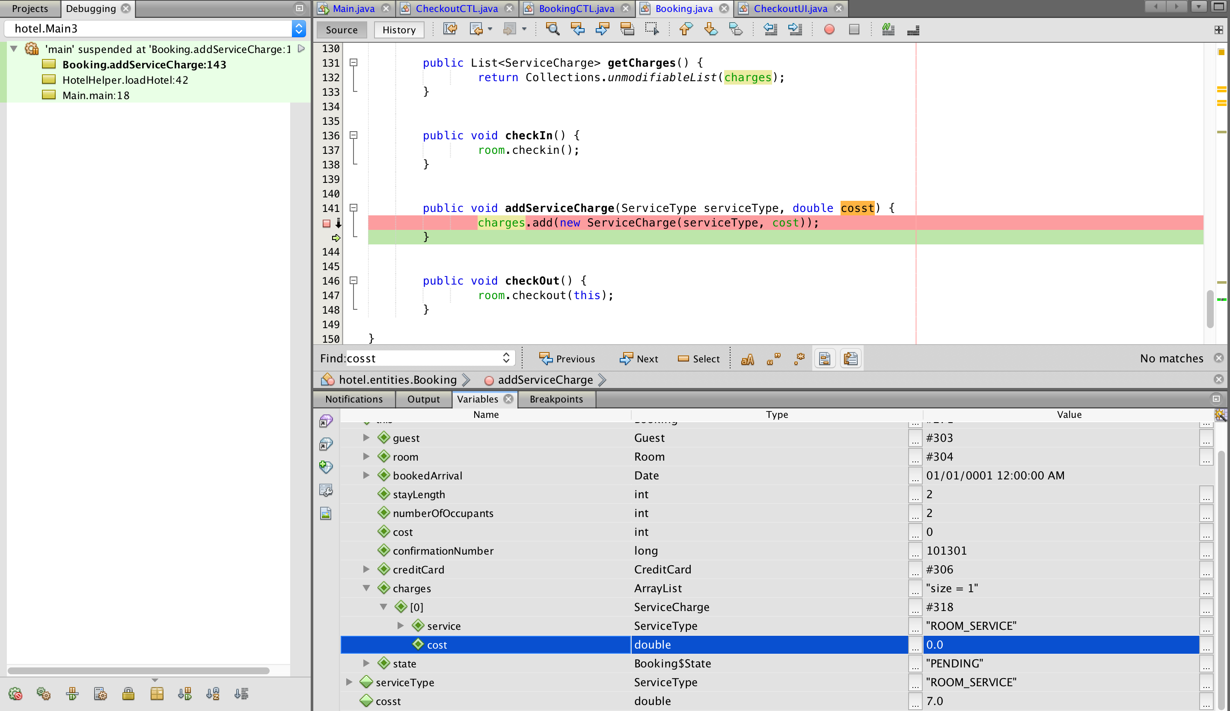

* In the variable list we can see clearly the parameter that pass the to the *addServiceCharge* method is not used inside the method because variable names are deferent

cosst = 7.0

cost = 0.0

* As above explain bug can be identified through the process



Figure 1: Before fixing error

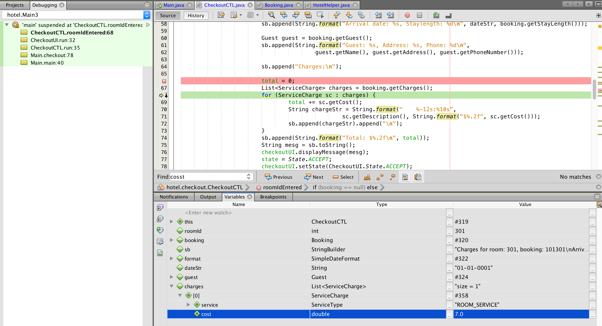

Figure 2: After fixing error



Figure 3: Before fixing error

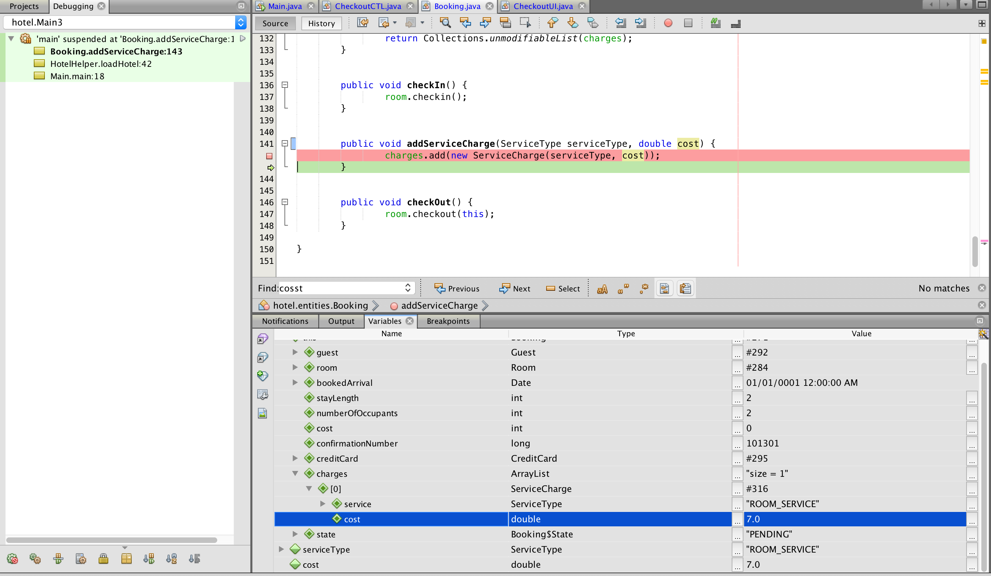

Figure 4: After fixing error

* Bug fixed and committed to the git repository

Committed link : <https://github.com/AkilaKanishka/HotelApp/commit/78e0b00f983117639a99ecc6514278127ca95806>

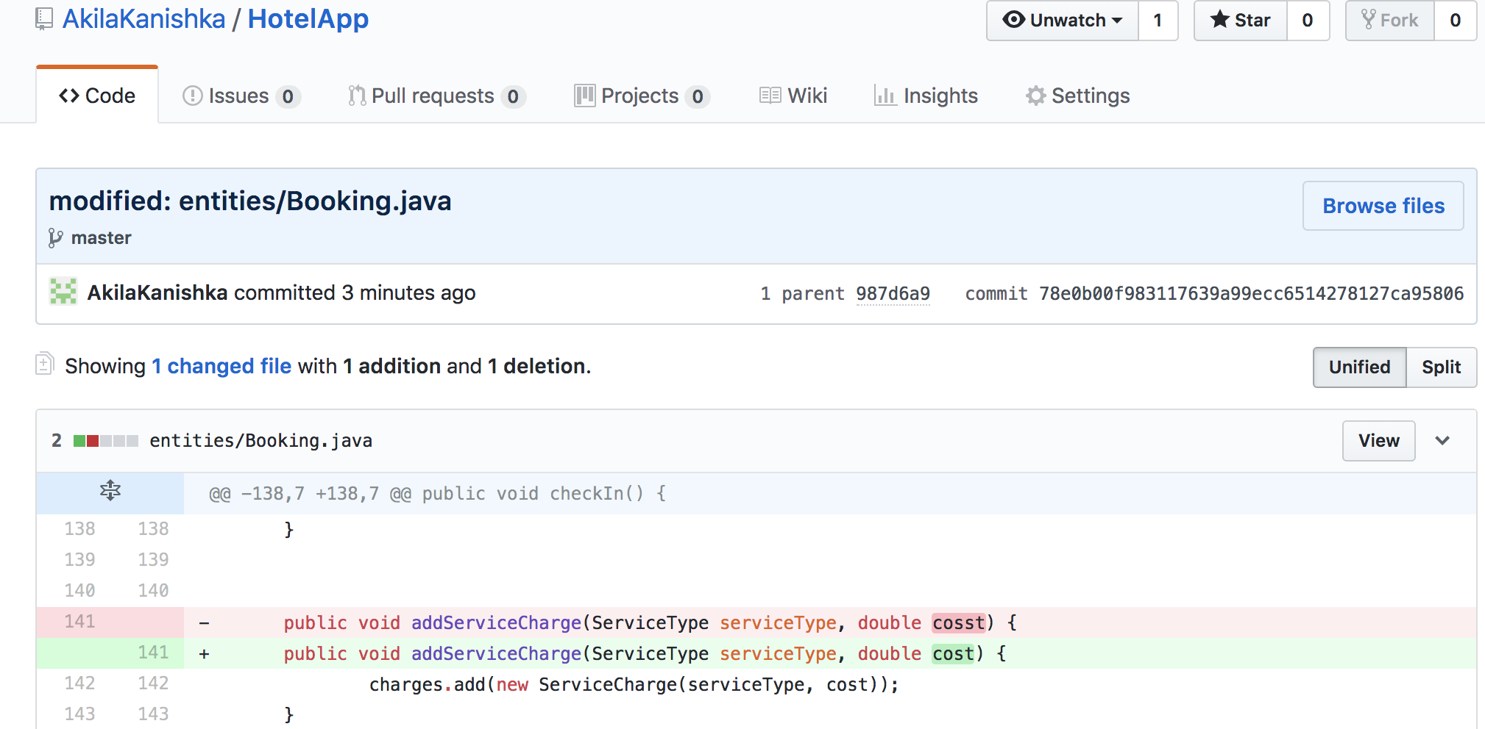

* Test case : <https://github.com/AkilaKanishka/HotelApp/blob/master/test/BookingTest.java>

1. It is possible to charge a room for service after the guest has checked out

This issue is appearing because of the booking object has not been removed from the list after checkout

Following process demonstrate how this bug can be identified by debugging the code

* The bug is related to the checkout so I set the debug point in checkoutCTL.java file at line number 45

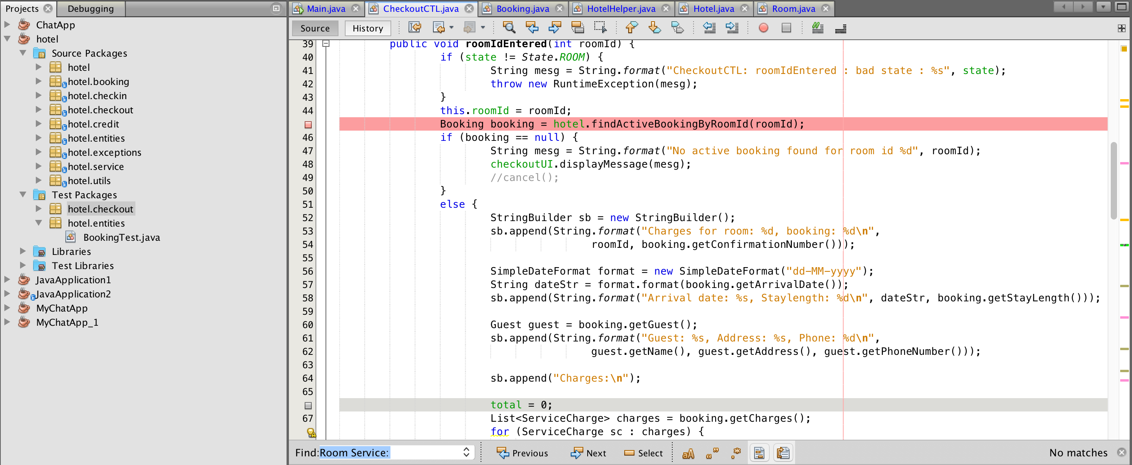

* In checkoutCTL.java file booking object is taken by *findActiveBookingByRoomId* method which is define in the Hotel.java file
* When I check that method in Hotel.java file that method return the booking object from activeBookingsByRoomId Map

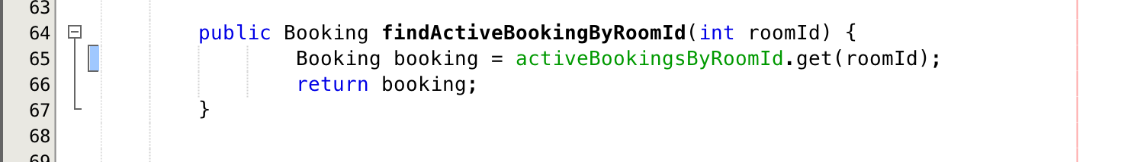

* The values are added to the *activeBookingsByRoomId* Map by *checkin* method

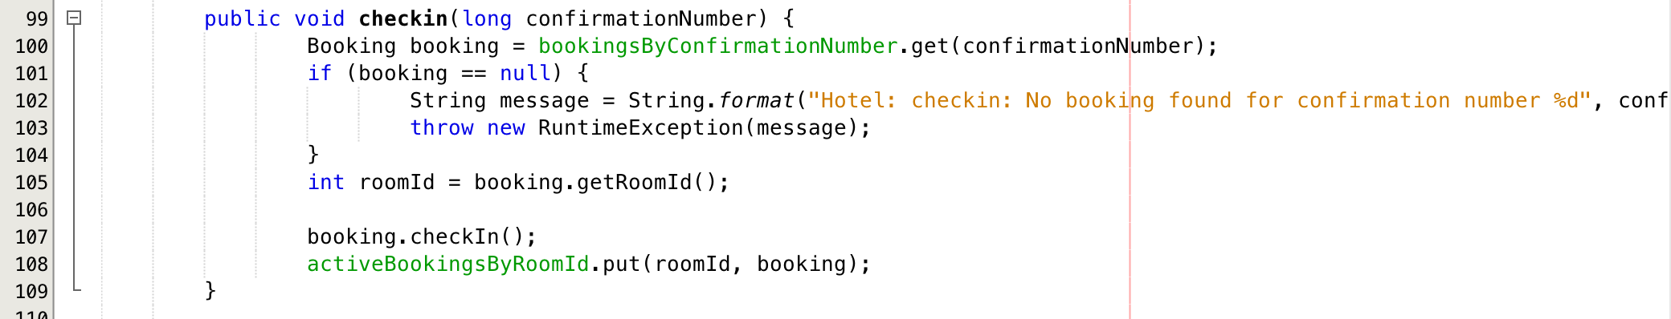

* But when it checkout that booking object is not removed from *activeBookingsByRoomId* Map

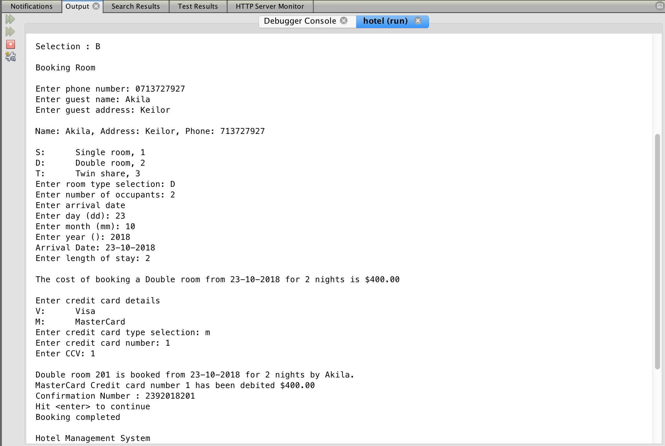

Figure 2.1: Before fixing error

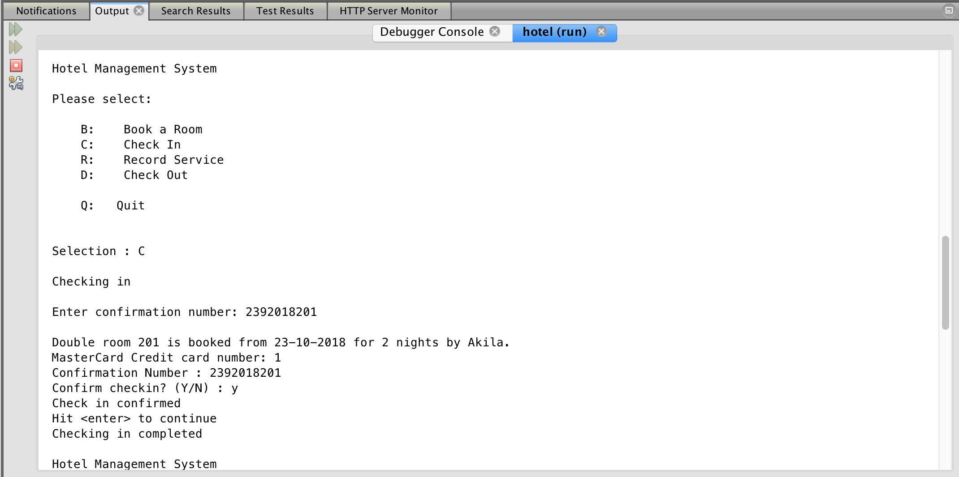

Figure 2.2: Before fixing error

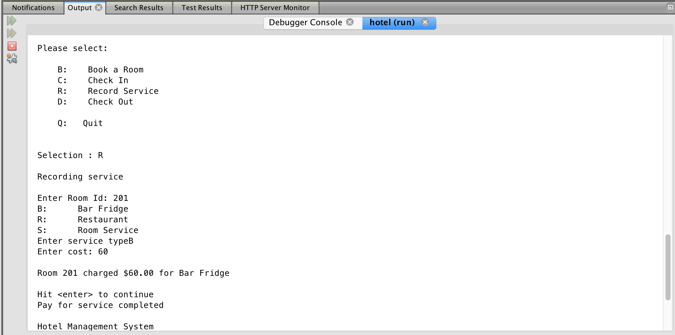

Figure 2.3: Before fixing error

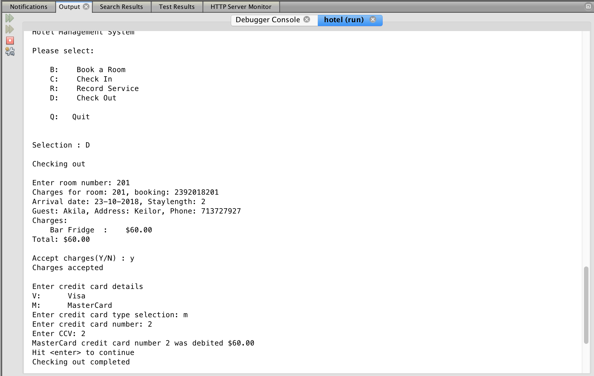

Figure 2.4: Before fixing error

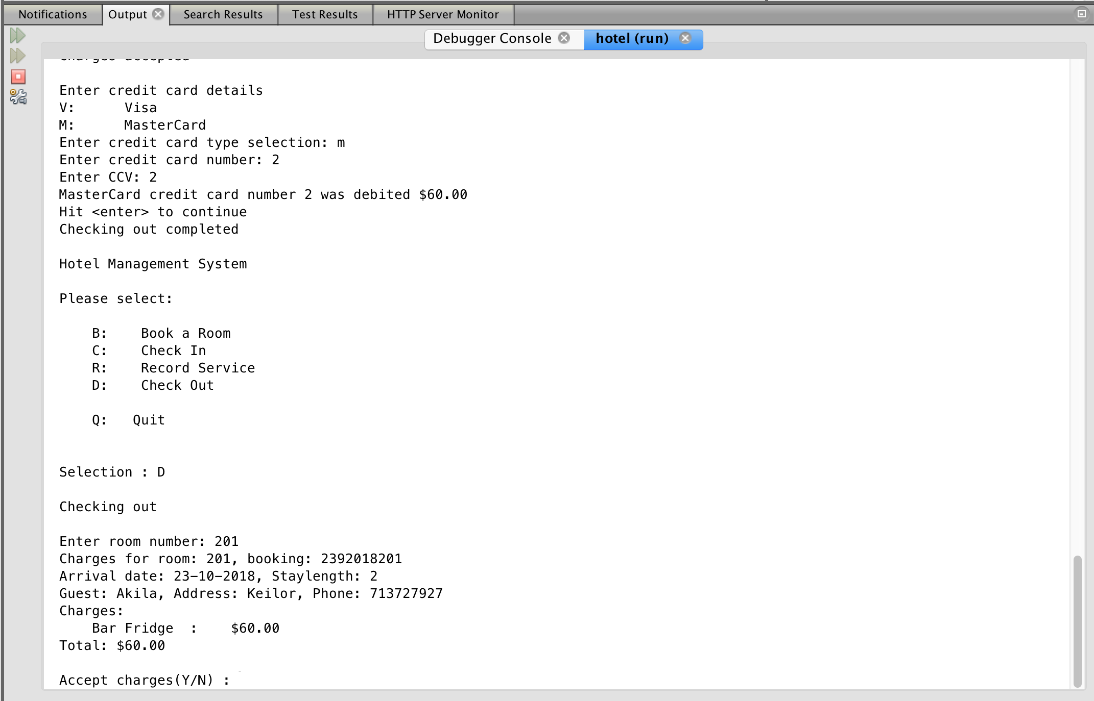

Figure 2.5: Before fixing error

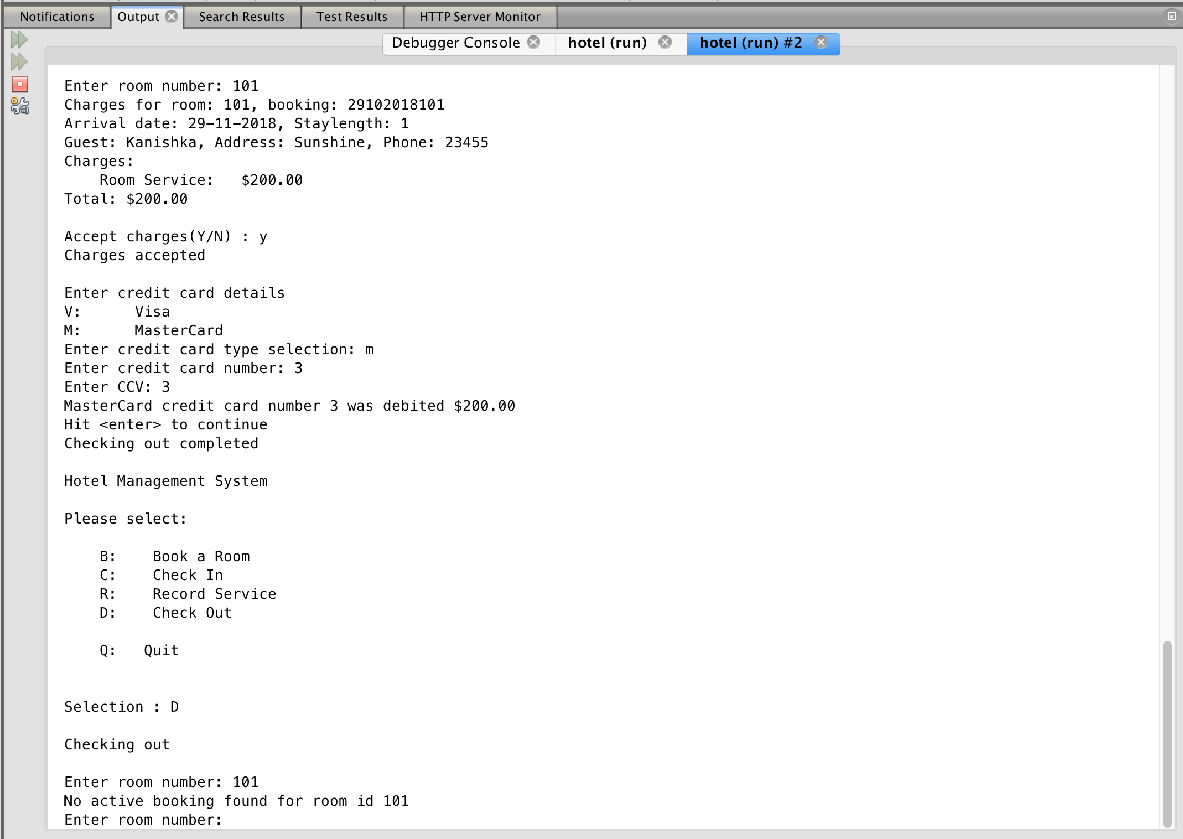

Figure 2.6: After fixing error

* Bug fixed and committed to the git repository

Committed link: <https://github.com/AkilaKanishka/HotelApp/commit/45f1567f73e4eedc78787fcf19238f9fcd15b0c6>

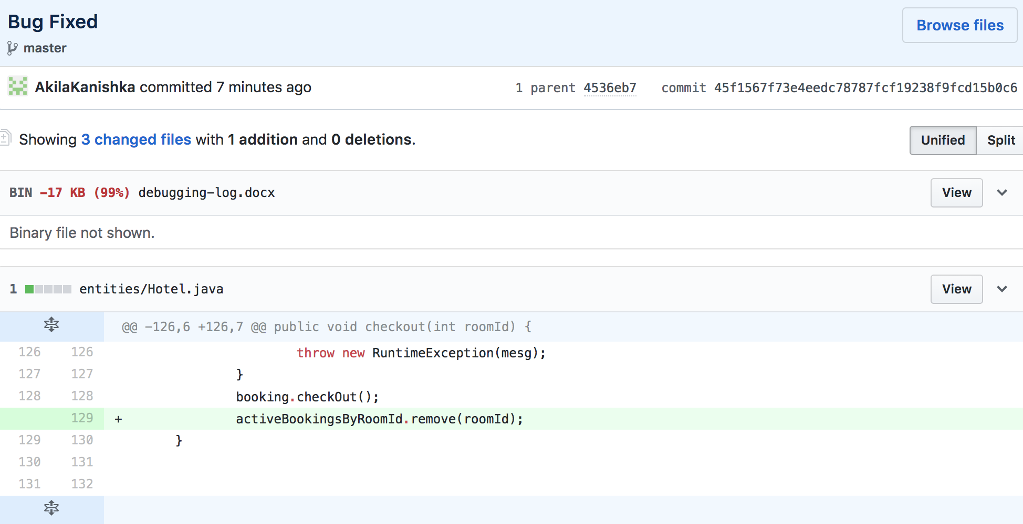

* Test case : <https://github.com/AkilaKanishka/HotelApp/blob/master/test/CheckoutCTLTest.java>